Sprint 2 – Accuracy Design Document

November 20, 2023

Table of Contents

1. Executive Summary 3

1.1 Project Overview 3

1.2 Purpose and Scope of this Specification 3

2. Product/Service Description 3

2.1 Product Context 3

2.2 User Characteristics 3

2.3 Assumptions 3

2.4 Constraints 3

2.5 Dependencies 4

3. Requirements 4

3.1 Functional Requirements 5

3.2 Security 5

3.2.1 Protection 5

3.2.2 Authorization and Authentication 6

3.3 Portability 6

4. Requirements Confirmation/Stakeholder sign-off 6

5. System Design 6

5.1 Algorithm 6

5.2 System Flow 6

5.3 Software 6

5.4 Hardware 6

5.5 Test Plan 7

5.6 Task List/Gantt Chart 7

5.7 Staffing Plan 7

# Executive Summary

## Project Overview

This project is to test our groups and individual ability to use software engineering skills to design a robot to follow a set of steps for Professor Eckert. All of which display accuracy for optimal performance in the robotics Triathlon.

<https://monmouth.desire2learn.com/d2l/le/content/316748/viewContent/3838976/View>

## Purpose and Scope of this Specification

This project is going to run a robot around HH208 with certain measurements to successfully display its accuracy to Professor Eckert. The measurements, speaking a set of words, code program, and lights, plan, and all requirements will be within scope. Out of scope would be anywhere the robot rolls outside of these measurements or does not speak the correct set of words at the proper location or does not follow the correct code, light sequence, plan and requirements.

# Product/Service Description

The general factors that affect the product are the code used to run the robot and any outside factors that will disturb its track. Also, the condition of the robot could affect it, all of which give reason to why we need specific requirements, so the robot runs the correct course.

## Product Context

The robot is related to the Sphero coding system program by a Bluetooth connection. The code directs the robot to do certain tasks which are made up by the user (our group).

## User Characteristics

Students - Our group of three will be users of this product. We all have limited experience with it and our technical expertise is not the best, but we all have a general grasp of how to use it. We are in the learning stage and have the basic skills to design this robot and use it.

Professor - Professor Eckert has plenty of experience with this product and has enough technical expertise to teach a class on it.

## Assumptions

Some assumptions that could affect the requirements.

- Lost equipment

- Not knowing the correct code to go with correct measurements

- The Hh208 room not being available

- Broken equipment

- If the Sphero site is not working

-Uneven floor

-The tape affecting the robot rolling

## Constraints

- Due dates

- Resources

- HH208 room availability

- Types of code blocks available

## Dependencies

- Coding must be completed for the robot to be tested

- The room must be available to test the robot

# Requirements

## Accuracy:

1. On the floor of room HH208, there will be two large circles 5’2” (figure eight) marked with blue tape, which will be the route that the robot will run 5 times.
2. The robot will be placed at the starting point. The starting point is in the square blue tape marked on the floor (exactly at the union of both circles).
3. At the starting point, the robot will start and go around the two 5’2” circles to make a firgure eight, looping 5 times.
4. When finished, the robot will speak “I am the winner” and flash multicolored lights for 5 seconds
5. The robot is required to arrive exactly at the starting point after traveling the entire path.
6. During the performance, the robot must not collide with any objects.

## Functional Requirements

| Req# | Requirement | Comments | Priority | Date Rvwd | SME Reviewed / Approved |
| --- | --- | --- | --- | --- | --- |
| ENDUR_1 | There will be two large circles 5’2” (figure eight) marked with blue tape. | The blue tape is peeling off from the floor and that might be an impediment for the robot to roll over the blue tape, but giving proper acceleration the robot would stay on track. |  | 11/20/23 | Approved |
| **ENDUR_3** | At the starting point, the robot will start and go around the two 5’2” circles to make a firgure eight, looping 5 times. | Meets the requirements |  | 11/20/23 | Approved |
| **ENDUR_4** | When finished, the robot will speak “I am the winner” and flash multicolored lights for 5 second | Meets the requirements |  | 11/20/23 | Approved |
| **ENDUR_5** | The robot is required to arrive exactly at the starting point after traveling the entire path | Meets the requirements |  | 11/20/23 | Approved |
| **ENDUR_6** | During the performance, the robot must not collide with any objects. | Meets the requirements |  | 11/20/23 | Approved |

## Security

### Protection

* There is one chosen person to hold onto the robot, making sure it does not go missing. There is only allowed one Bluetooth connection at a time so there is no accidental access. All activity with the robot is logged as well to make sure everything is in order.

### Authorization and Authentication

You need an account to access the Sphero app and the newly released version. You must also have an authorized computer.

## Portability

The robot's portability is versatile. The robot can be run anywhere and will run the correct route if it does not hit any obstacles. As for writing the code, the Sphero site is not so versatile. You cannot do all it offers on Windows, so we must use a Mac computer for the coding to work and get the graphs. But besides that, the robot is easily portable and can be used anywhere with enough space and internet and Bluetooth connections.

# Requirements Confirmation/Stakeholder sign-off

|  |  |  |
| --- | --- | --- |
| Meeting Date | Attendees (name and role) | Comments |
| 11/20/23 | Jon Veltri, Jack McGovern, Leslie B | Confirmed all |

# System Design

## ***Alg***orithm

1. Place the powered-on robot at the starting point.
2. Robot starts running the first circle 5’2”.
3. Robot continues running the second circle 5’2”.
4. Robot reaches the end/starting, after he completes figure number eight.
5. Repeat steps “2 to 4” (Loop).
6. Robot reaches the end point
7. Robot says: “I am the winner” and flash multicolored lights for 5 seconds.

## System Flow

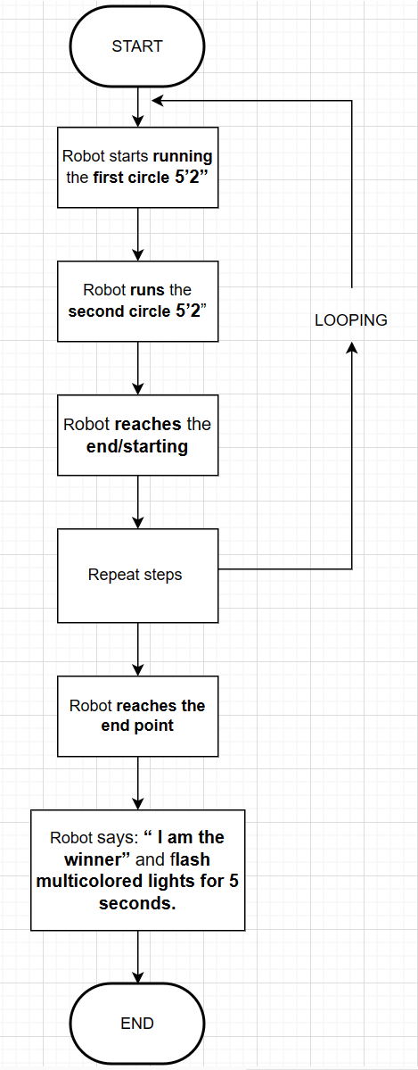

## Software

The official and supported Sphero EDU app was used to develop and run the code. The Sphero program utilizes block code (Shown below) to program the robots.

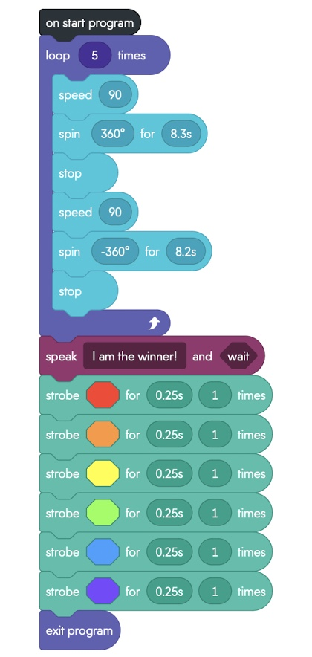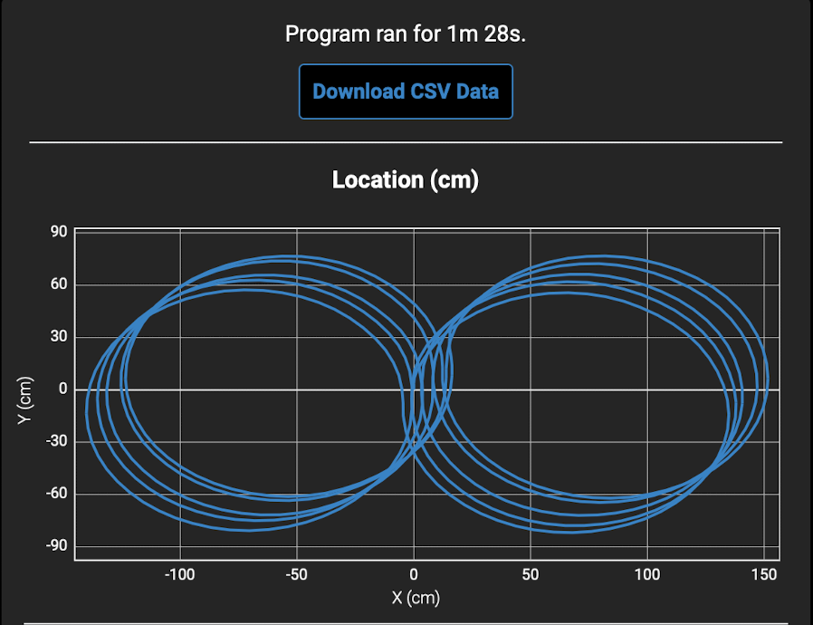

## Hardware

Laptops and desktops were used to develop the code and test the application on the Sphero BOLT robot.

## Test Plan

| **Reason for Test Case** | **Test Date** | **Expected Output** | **Observed Output** | **Staff Name** | **Pass/Fail** |
| --- | --- | --- | --- | --- | --- |
| Test of the first circle | 11/20/23 | The robot will successfully travel around the first circle | The robot made a smaller circle and went off course | All | Fail |
| Test of the first circle | 11/20/23 | The robot will successfully travel around the first circle | The robot made a bigger circle than expected | All | Fail |
| Test of the first circle | 11/20/23 | The robot will successfully travel around the first circle | The robot traveled around the circle correctly | All | Pass |
| Test of the second circle | 11/20/23 | The robot will successfully travel around the first and second circle | The robot traveled in a larger circle on the opposite side | All | Fail |
| Test of the second circle | 11/20/23 | The robot will successfully travel around the first and second circle | The robot successfully went around both circles | All | Pass |
| Test of both circles 5 times | 11/20/23 | The robot will travel around both circles five times | The robot successfully traveled around | All | Pass |

## Task List/Gantt Chart

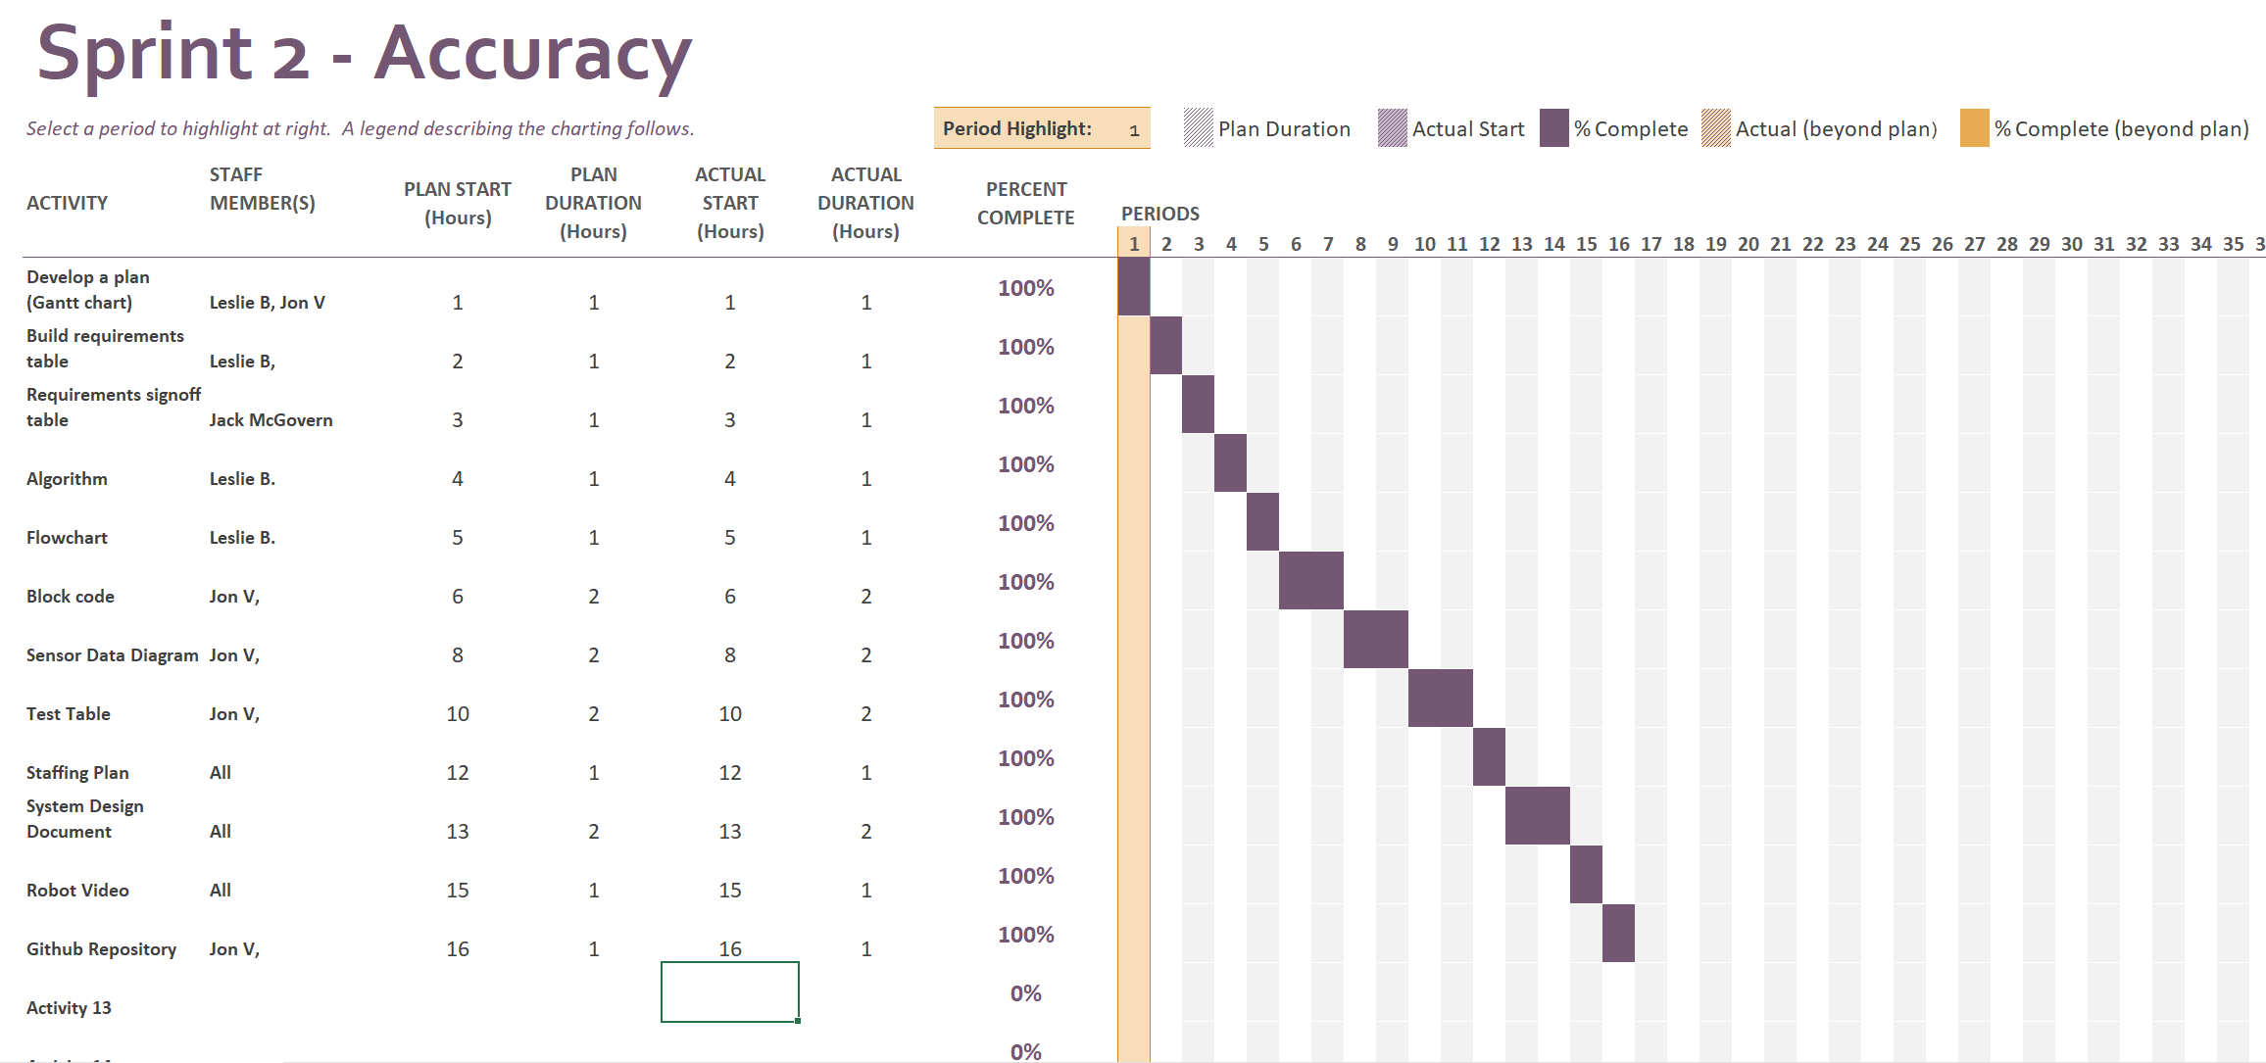

## Staffing Plan

| Name | Role | Responsibility | Reports To |
| --- | --- | --- | --- |
| Jon V. | Coding | Code the robot, setup the GitHub, record the robot video | Everyone |
| Jack M. | SDD | Fill in the missing information in the system design document | Everyone |
| Leslie B. | Gantt Chart / SDD | Fill in the missing information in the system design document; Also fill out the Gantt chart | Everyone |